Lab Taks-3

Submission Guidelines-
- Rename the file with your serial number only
- Must submit within time that will be discussed in class VUES
- Must include resources for all the section in the table
Question- 1

Draw five storied building with windows and a front door

Graph Plot (Picture)-

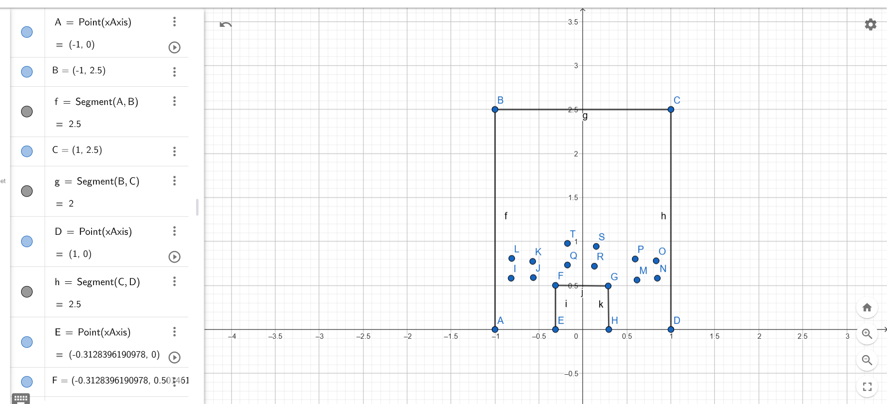
Code-
#include <windows.h>
#include <GL/glut.h>

void window(float x1, float y1, float x2, float y2)
{
glBegin(GL_POLYGON);
glColor3ub(173, 216, 230);
glVertex2f(x1, y1);
glVertex2f(x2, y1);
glVertex2f(x2, y2);
glVertex2f(x1, y2);
glEnd();

glLineWidth(2.0f);
glBegin(GL_LINE_LOOP);
glColor3ub(255, 255, 255);
glVertex2f(x1, y1);
glVertex2f(x2, y1);
glVertex2f(x2, y2);
glVertex2f(x1, y2);
glEnd();
}

void display() {
glClear(GL_COLOR_BUFFER_BIT);

glBegin(GL_POLYGON);
glColor3ub(46, 128, 202);
glVertex2f(-1.5f, -1.0f);
glVertex2f(1.5f, -1.0f);
glVertex2f(1.5f, 7.7f);
glVertex2f(-1.5f, 7.7f);
glEnd();

glBegin(GL_POLYGON);
glColor3ub(139, 69, 19);
glVertex2f(-0.5f, -1.0f);
glVertex2f(0.5f, -1.0f);
glVertex2f(0.5f, 2.0f);
glVertex2f(-0.5f, 2.0f);
glEnd();

glLineWidth(3.0f);
glBegin(GL_LINE_LOOP);
glColor3ub(0, 0, 0);
glVertex2f(-0.5f, -1.0f);
glVertex2f(0.5f, -1.0f);
glVertex2f(0.5f, 2.0f);
glVertex2f(-0.5f, 2.0f);
glEnd();

for (float y = 2.5f; y <= 6.5f; y += 1.0f) {
window(-1.3f, y, -0.5f, y + 0.6f);
}

for (float y = 2.5f; y <= 6.5f; y += 1.0f) {
window(0.5f, y, 1.3f, y + 0.6f);
}

window(-0.3f, 6.4f, 0.3f, 7.2f);
window(-0.3f, 4.4f, 0.3f, 5.2f);
window(-0.3f, 2.4f, 0.3f, 3.2f);

glFlush();
}

int main(int argc, char** argv) {
glutInit(&argc, argv);
glutInitWindowSize(600, 800);
glutCreateWindow("OpenGL Building");

gluOrtho2D(-2.5, 2.5, -2, 8); // Adjusted view
glutDisplayFunc(display);
glutMainLoop();
return 0;
}

Output Screenshot (Full Screen)-

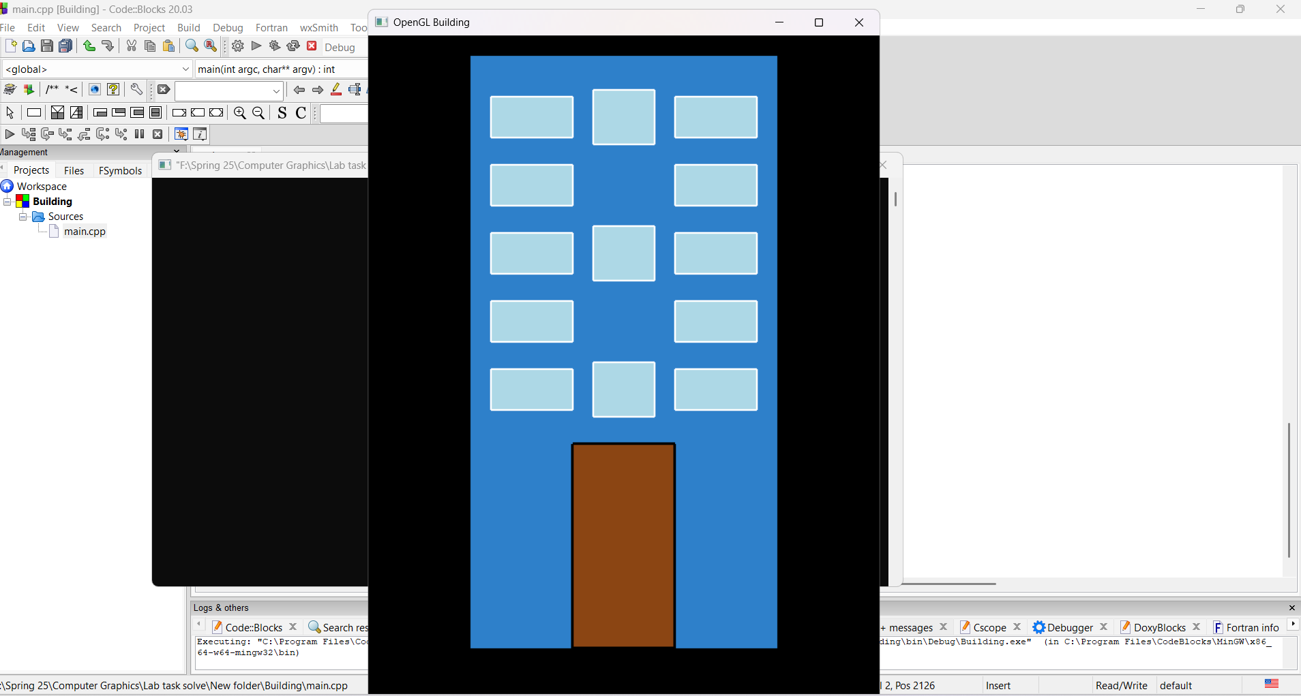

Question- 2

Draw a tree

Graph Plot (Picture)-
Resource – Youtube
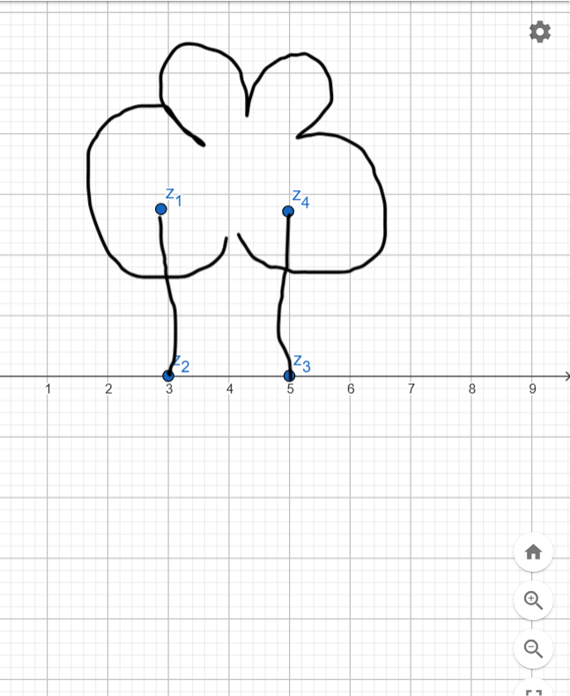
Code-
#include <GL/glut.h>
#include <cmath>

void drawCircle(GLfloat cx, GLfloat cy, GLfloat r, int num_segments) {
glBegin(GL_POLYGON);
for (int i = 0; i < num_segments; i++) {
float theta = 2.0f * M_PI * float(i) / float(num_segments);
float x = r * cosf(theta);
float y = r * sinf(theta);
glVertex2f(cx + x, cy + y);
}
glEnd();
}

void init(void) {
glClearColor(1.0, 1.0, 1.0, 1.0);
glMatrixMode(GL_PROJECTION);
gluOrtho2D(0, 400, 0, 500);
}

void display(void) {
glClear(GL_COLOR_BUFFER_BIT);

// Tree trunk
glColor3ub(139, 69, 19);
glBegin(GL_POLYGON);
glVertex2f(180, 100);
glVertex2f(220, 100);
glVertex2f(220, 250);
glVertex2f(180, 250);
glEnd();

// Tree leaves using circles
glColor3ub(0, 153, 0);
drawCircle(200, 250, 60, 50);
drawCircle(160, 220, 50, 50);
drawCircle(240, 220, 50, 50);
drawCircle(180, 280, 50, 50);
drawCircle(220, 280, 50, 50);

glFlush();
glutSwapBuffers();
}

int main(int argc, char **argv) {
glutInit(&argc, argv);
glutInitDisplayMode(GLUT_DOUBLE | GLUT_RGB);
glutInitWindowSize(400, 500);
glutInitWindowPosition(100, 100);
glutCreateWindow("OpenGL Tree");
init();
glutDisplayFunc(display);
glutMainLoop();
return 0;
}

Output Screenshot (Full Screen)-
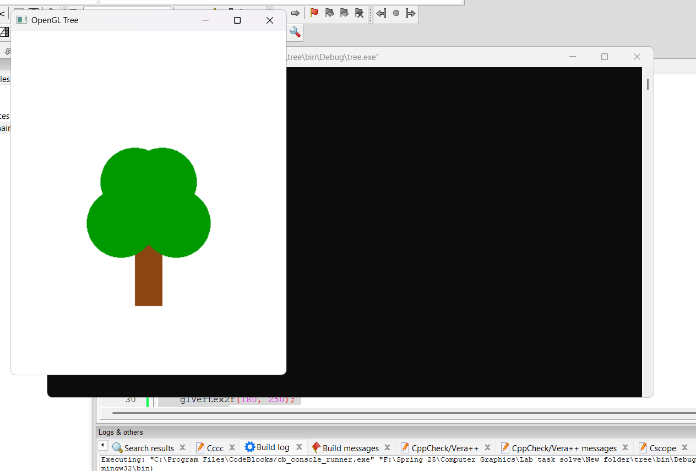

Question- 3

Draw a lamppost with black background

Graph Plot (Picture)-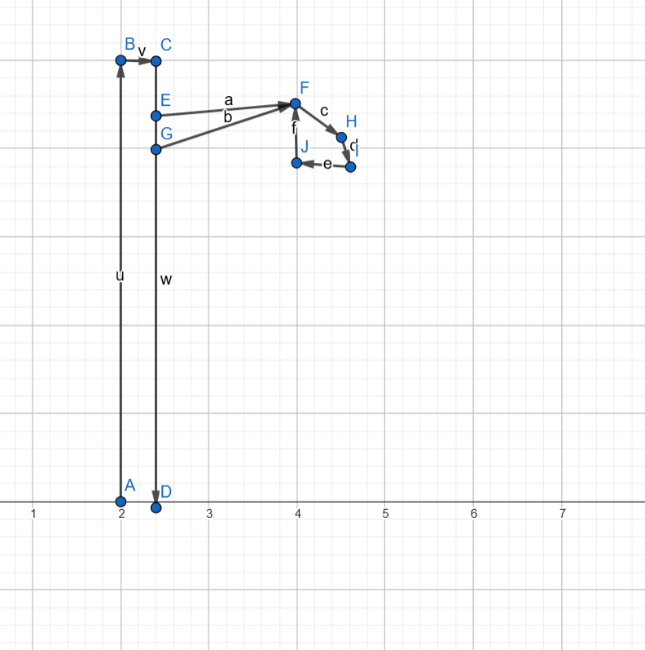

Code-

#include <GL/glut.h>

void drawLamppost() {
glClear(GL_COLOR_BUFFER_BIT);

glColor3f(0.6, 0.6, 0.6);
glBegin(GL_QUADS);
glVertex2f(2.4, 0.0);
glVertex2f(2.6, 0.0);
glVertex2f(2.6, 4.5);
glVertex2f(2.4, 4.5);
glEnd();

glColor3f(0.4, 0.4, 0.4);
glBegin(GL_QUADS);
glVertex2f(2.0, -0.2);
glVertex2f(3.0, -0.2);
glVertex2f(3.0, 0.0);
glVertex2f(2.0, 0.0);
glEnd();

glColor3f(0.6, 0.6, 0.6);
glBegin(GL_QUADS);
glVertex2f(2.0, 4.5);
glVertex2f(3.8, 4.5);
glVertex2f(3.8, 4.3);
glVertex2f(2.0, 4.3);
glEnd();

glColor3f(1.0, 1.0, 0.0);
glBegin(GL_POLYGON);
glVertex2f(3.5, 4.3);
glVertex2f(4.0, 4.0);
glVertex2f(4.2, 3.7);
glVertex2f(3.8, 3.5);
glVertex2f(3.3, 3.7);
glEnd();

glFlush();
}

void init() {
glClearColor(0.0, 0.0, 0.0, 1.0); // Black background
glMatrixMode(GL_PROJECTION);
glLoadIdentity();
gluOrtho2D(0.0, 6.0, -1.0, 6.0); // Adjusted coordinate system
}

int main(int argc, char** argv) {
glutInit(&argc, argv);
glutInitDisplayMode(GLUT_SINGLE | GLUT_RGB);
glutInitWindowSize(800, 600);
glutCreateWindow("Lamppost Drawing");
init();
glutDisplayFunc(drawLamppost);
glutMainLoop();
return 0;
}
Output Screenshot (Full Screen)-
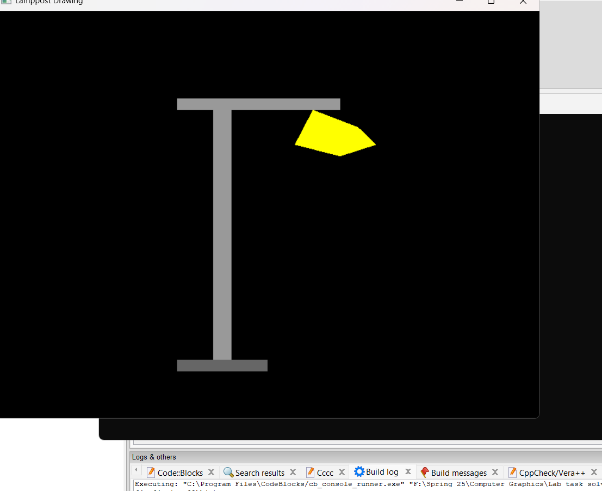

Question- 4

Draw a bench

Graph Plot (Picture)-
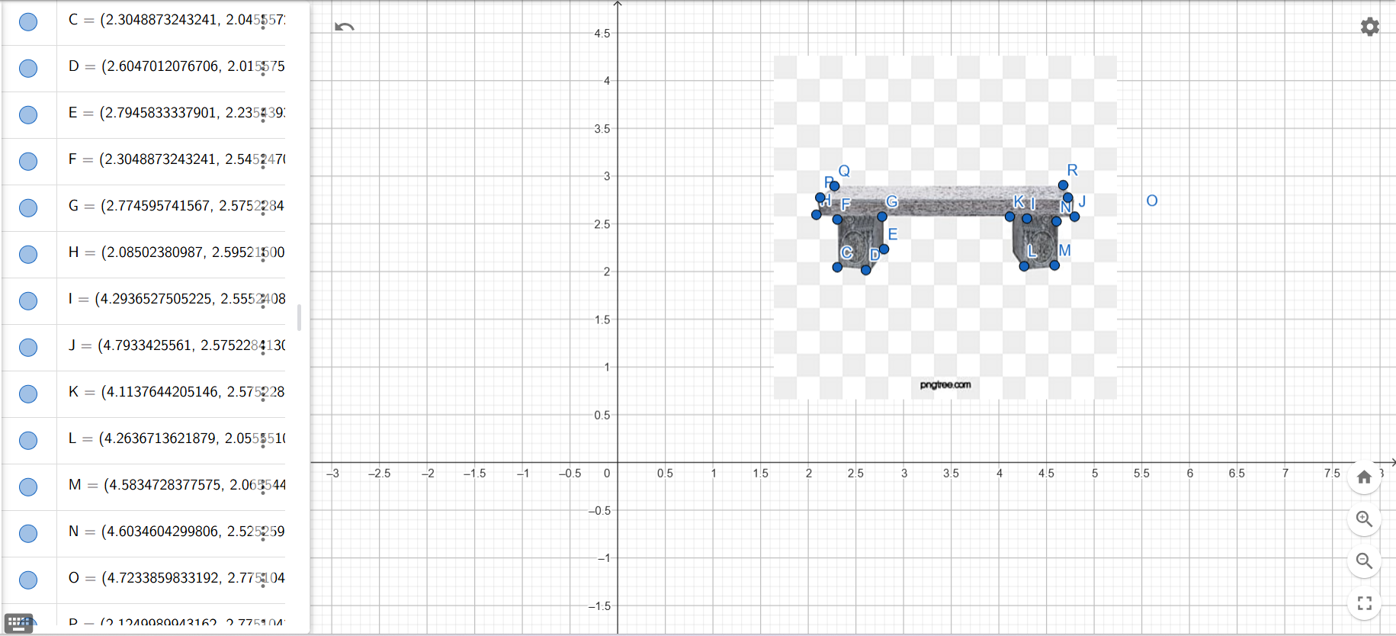
Code-
#include <windows.h>
#include <GL/glut.h>

// Adjusted Bench Coordinates (More structured)
float seat[] = {2.0, 3.0, 5.0, 3.0, 5.0, 2.7, 2.0, 2.7}; // Seat
float leftLeg[] = {2.3, 2.7, 2.5, 2.7, 2.5, 1.5, 2.3, 1.5}; // Left Leg
float rightLeg[] = {4.5, 2.7, 4.7, 2.7, 4.7, 1.5, 4.5, 1.5}; // Right Leg
float backrest[] = {2.0, 3.5, 5.0, 3.5, 5.0, 3.0, 2.0, 3.0}; // Backrest

void drawQuad(float coords[]) {
glBegin(GL_QUADS);
glVertex2f(coords[0], coords[1]);
glVertex2f(coords[2], coords[3]);
glVertex2f(coords[4], coords[5]);
glVertex2f(coords[6], coords[7]);
glEnd();
}

void drawBench() {
// Draw the Bench Components
glColor3f(0.6f, 0.6f, 0.6f); // Grey Seat
drawQuad(seat);

glColor3f(0.4f, 0.4f, 0.4f); // Darker Legs
drawQuad(leftLeg);
drawQuad(rightLeg);

glColor3f(0.5f, 0.5f, 0.5f);
drawQuad(backrest);
}

void display() {
glClear(GL_COLOR_BUFFER_BIT);
drawBench();
glFlush();
}

void reshape(int w, int h) {
glViewport(0, 0, w, h);
glMatrixMode(GL_PROJECTION);
glLoadIdentity();
gluOrtho2D(0.0, 6.0, 0.0, 6.0);
glMatrixMode(GL_MODELVIEW);
}

int main(int argc, char** argv) {
glutInit(&argc, argv);
glutInitDisplayMode(GLUT_SINGLE | GLUT_RGB);
glutInitWindowSize(800, 600);
glutCreateWindow("OpenGL Bench");
glutDisplayFunc(display);
glutReshapeFunc(reshape);
glClearColor(1.0, 1.0, 1.0, 1.0);
glutMainLoop();
return 0;
}
Output Screenshot (Full Screen)- 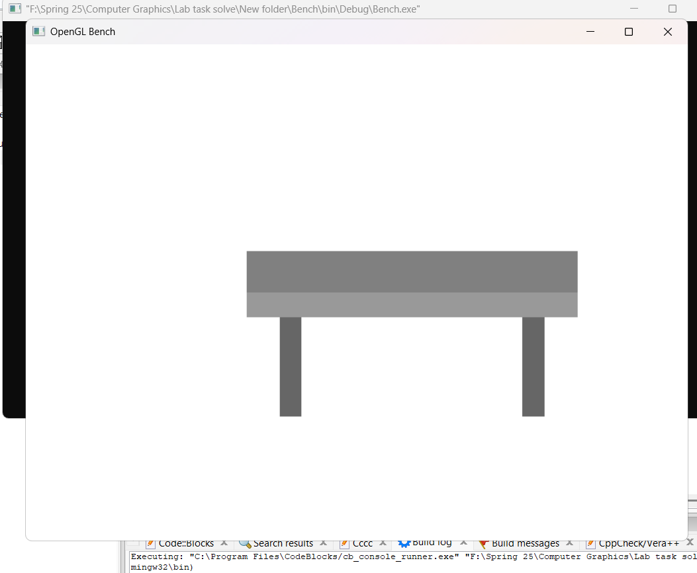

Question- 5

Use the building, tree, lamppost and bench to create a scenario

Graph Plot (Picture)-
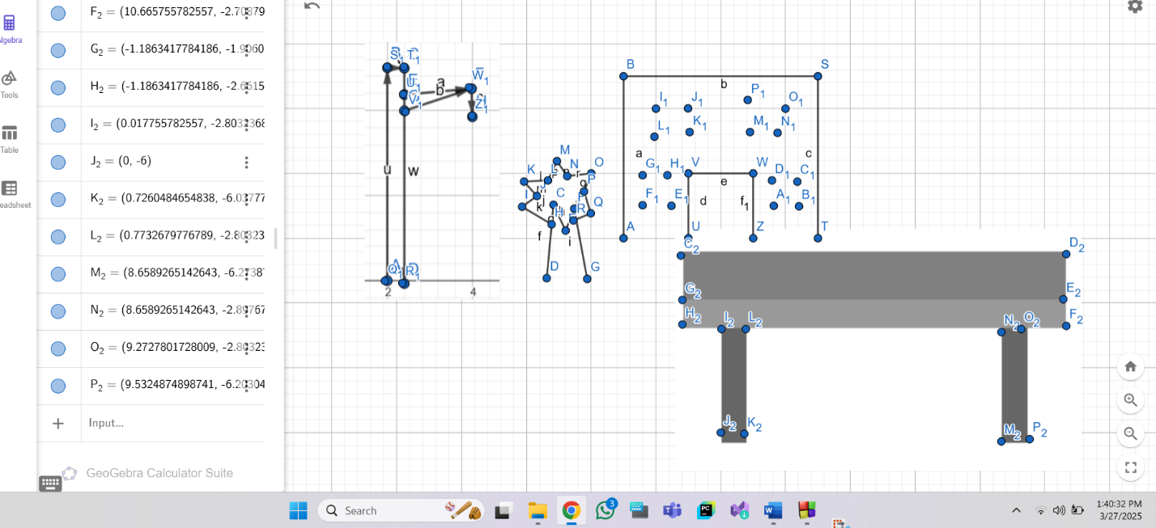
Code-#include <windows.h>
#include <GL/glut.h>
#include <cmath>

// Draw a night-time background (dark sky and ground)
void drawBackground() {
glClearColor(0.1, 0.1, 0.2, 1.0); // Dark blue sky for night
glClear(GL_COLOR_BUFFER_BIT);

glColor3ub(34, 34, 34); // Dark ground for night
glBegin(GL_POLYGON);
glVertex2f(-4.0, -1.0);
glVertex2f(4.0, -1.0);
glVertex2f(4.0, 1.0);
glVertex2f(-4.0, 1.0);
glEnd();
}

// Draw a circle for tree leaves
void drawCircle(GLfloat cx, GLfloat cy, GLfloat r, int num_segments) {
glBegin(GL_POLYGON);
for (int i = 0; i < num_segments; i++) {
float theta = 2.0f * M_PI * float(i) / float(num_segments);
float x = r * cosf(theta);
float y = r * sinf(theta);
glVertex2f(cx + x, cy + y);
}
glEnd();
}

// Draw the 5-story building with windows
void drawBuilding() {
glColor3ub(46, 128, 202); // Light building color
glBegin(GL_POLYGON);
glVertex2f(-1.5f, -1.0f);
glVertex2f(1.5f, -1.0f);
glVertex2f(1.5f, 7.0f); // 5 stories building
glVertex2f(-1.5f, 7.0f);
glEnd();

// Windows (5 floors of windows with dim light)
glColor3ub(173, 216, 230); // Soft light blue for night windows
for (float y = 1.0f; y <= 5.5f; y += 1.2f) {
for (float x = -1.2f; x <= 1.0f; x += 1.2f) {
glBegin(GL_POLYGON);
glVertex2f(x, y);
glVertex2f(x + 0.5f, y);
glVertex2f(x + 0.5f, y + 0.6f);
glVertex2f(x, y + 0.6f);
glEnd();
}
}
}

// Draw the tree with circular leaves behind the building
void drawTree() {
// Tree trunk (placed behind the building)
glColor3ub(139, 69, 19); // Darker trunk color for night
glBegin(GL_POLYGON);
glVertex2f(-2.0, -1.0);
glVertex2f(-1.7, -1.0);
glVertex2f(-1.7, 3.5); // Taller trunk
glVertex2f(-2.0, 3.5); // Taller trunk
glEnd();

// Tree leaves (circle-like foliage)
glColor3ub(0, 153, 0); // Dark green for leaves at night
drawCircle(-2.0, 4.5, 1.5, 50);
drawCircle(-1.5, 5.5, 1.2, 50);
drawCircle(-2.5, 5.5, 1.2, 50);
drawCircle(-2.0, 6.5, 1.0, 50);
drawCircle(-1.5, 6.5, 1.0, 50);
}

// Draw the lamppost beside the bench with night-time lighting
void drawLamppost() {
glColor3f(0.6, 0.6, 0.6); // Lamppost color
glBegin(GL_QUADS);
glVertex2f(1.7, 0.0);
glVertex2f(1.8, 0.0);
glVertex2f(1.8, 4.5);
glVertex2f(1.7, 4.5);
glEnd();

glColor3f(0.6, 0.6, 0.6); // Top of lamppost
glBegin(GL_QUADS);
glVertex2f(1.5, 4.5);
glVertex2f(2.0, 4.5);
glVertex2f(2.0, 4.3);
glVertex2f(1.5, 4.3);
glEnd();

// Light (circular) with bright yellow for night-time glow
glColor3f(1.0, 1.0, 0.0); // Yellow light
float radius = 0.3;
int num_segments = 30;
glBegin(GL_POLYGON);
for (int i = 0; i < num_segments; i++) {
float theta = 2.0f * M_PI * float(i) / float(num_segments);
float x = radius * cosf(theta);
float y = radius * sinf(theta);
glVertex2f(1.85f + x, 4.3f + y);
}
glEnd();
}

// Draw the bench on the right side of the scene
void drawBench() {
glColor3f(0.6f, 0.6f, 0.6f); // Bench seat color
glBegin(GL_QUADS);
glVertex2f(0.5, -0.8); // Moved to the right
glVertex2f(3.5, -0.8); // Moved to the right
glVertex2f(3.5, -1.0); // Moved to the right
glVertex2f(0.5, -1.0); // Moved to the right
glEnd();

glColor3f(0.4f, 0.4f, 0.4f); // Bench legs color
glBegin(GL_QUADS);
glVertex2f(0.6, -1.0); // Left leg
glVertex2f(0.7, -1.0); // Left leg
glVertex2f(0.7, -1.3); // Left leg
glVertex2f(0.6, -1.3); // Left leg
glEnd();

glBegin(GL_QUADS);
glVertex2f(3.4, -1.0); // Right leg
glVertex2f(3.5, -1.0); // Right leg
glVertex2f(3.5, -1.3); // Right leg
glVertex2f(3.4, -1.3); // Right leg
glEnd();
}

void display() {
drawBackground(); // Dark sky and ground for night-time
drawBuilding(); // Building with dimly lit windows
drawTree(); // Tree with circular leaves behind the building
drawLamppost(); // Lamppost with lighting
drawBench(); // Bench moved to the right side
glFlush();
}

void init() {
glMatrixMode(GL_PROJECTION);
glLoadIdentity();
gluOrtho2D(-4.0, 4.0, -2.0, 8.0);
}

int main(int argc, char** argv) {
glutInit(&argc, argv);
glutInitDisplayMode(GLUT_SINGLE | GLUT_RGB);
glutInitWindowSize(800, 600);
glutCreateWindow("OpenGL Night Scene");
init();
glutDisplayFunc(display);
glutMainLoop();
return 0;
}

Output Screenshot (Full Screen)-

